192521377-SUBASHREE.N
LAB EXPERIMENTS
EXP 8: Query with Sub Query& Correlated Query
OUTPUT:
1:
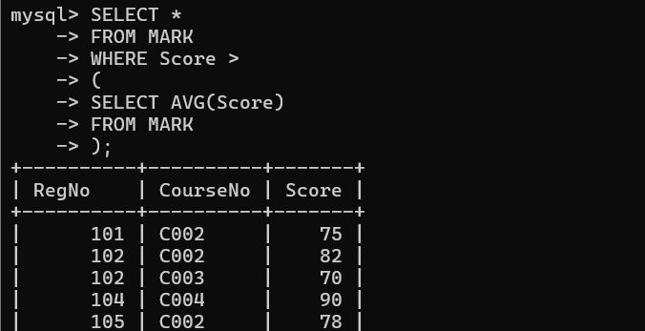
2:
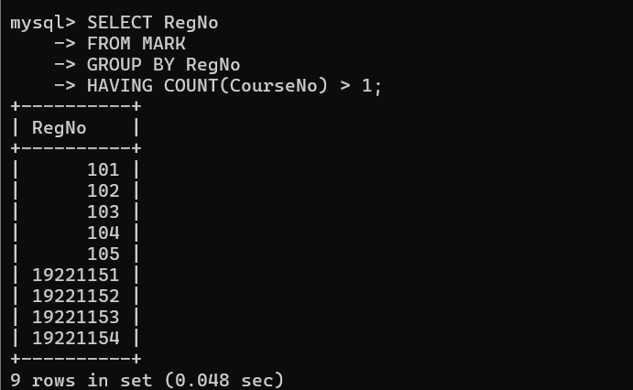
3:
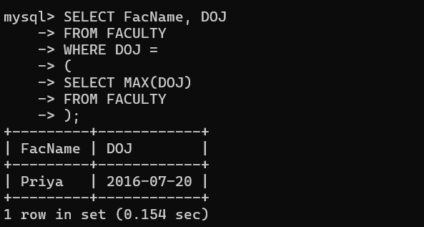
4:
